MAKERERE  UNIVERSITY

E-Intelligent

By
BSE 20-40
WEB BASED SYSTEM
DEPARTMENT OF NETWORKS
SCHOOL OF COMPUTING AND INFORMATICS TECHNOLOGY

A Project Report Submitted to the School of Computing and Informatics Technology
for the Study Leading to a Project in Partial Fulfillment of the
Requirements for the Award of the Degree of Bachelor of
Science in Software Engineering of Makerere University.

Supervisor
Supervisor name; Ms. Ruth Mbabazi
Department of Networks
School of Computing and Informatics Technology, Makerere University
Supervisor email: rmbabazi@cis.mak.ac.ug, Contact: +256-772-121696

November, 2020

Declaration
We, group BSE 20-40, hereby declare that the work presented is original and has never been submitted for an award to any university or institution of higher learning
# | Names | Registration Number | Student  Number
1 | LUMALA DAVID | 16/U/6679/EVE | 216003711
2 | RUZINDANA MOSES | 15/U/12452/EVE | 215004646
3 | KASOZI BENJAMIN | 16/U/5538/EVE | 216015602
4 | TUMUHAIRWE BRUNO | 12/U/14827/PS | 212011554

Approval

This project report titled E-intelligent has been submitted for examination with my approval as the supervisor of group BSE 20-40.

Supervisor name: Ms. Ruth Mbabazi
Department of Networks

School of Computing and Informatics Technology;

College of Computing and Information Sciences,

Makerere University

Signature: ................................................... Date: ............................

Supervisor

Dedication
As a result of our work, we hereby dedicate it to all the people who helped us achieve its results successfully, our families have been of tremendous support to us financially, spiritually and otherwise, Ms. Ruth Mbabazi the project supervisor who without hesitation took time to share her knowledge on the various information technology fields making it possible for us to complete our project.

Acknowledgements
The success of this report is a collaborative effort from colleagues and friends whom we owe our sincere gratitude. We thank the almighty God for keeping us safe and healthy throughout this project. A vote of thanks for the tireless support to our project supervisor, Ms. Ruth Mbabazi for guiding us during this project, and to all our fellow colleagues for their tireless effort and dedication during this period. The completion of this project could not have been possible without the support and cooperation of all group members, Lumala David, Ruzindana Moses ,Kasozi Benjamin and Tumuhairwe Bruno. Thank you for working together in resolving major programming issues and for your patience with changing requirements. We also appreciate the encouragement and financial support accorded to us by all our parents and relatives. May God endlessly reward you for being such a blessing to us.

Abstract
Uganda’s Unemployment Rate is expected to be 2.10 percent by the end of this quarter, according to Trading Economics global macro models and analysts’ expectations. In the long-term, the Uganda Unemployment Rate is projected to trend around 2.30 percent in 2020, according to our econometric models. This is partly due to the fact that there is a gap between what is actually taught by the university and the skills really needed in the job market, it is true that what is offered by the university is part of the knowledge needed for the graduate to get a job but is it enough to much up to the standards of the job market, Unfortunately for ICT graduates its so bad that they are sharing the market with the international or global market, meaning ICT graduates from other countries can come and take up jobs here as long as they are better at the job, this in away has created pressure on universities and higher institutions to assess whether they really deliver what employers perceive or expect any ICT graduate to bear for him/her to be relevant in the job market. This creates a need for a solution that will enable universities and tertiary institutions to assess their ranking in passing out market-relevant ICT graduates those e-intelligent, a web software that will help scout, review, analyze and report potential changes in that need addressing right from the students, graduates, institution administration up to the employers.

Table of contents
Declaration i
Approval i
Dedication ii
Acknowledgements iii
Abstract iv
List of tables vi
List of figures vi
1. INTRODUCTION 1
1.1. Background of project 1
1.2. Scope of the project 1
2. SYSTEM SPECIFICATIONS 3
2.1. Version of requirements and version control 3
2.2. Input 3
2.3. Output 5
2.4. Functionality 6
2.5. Limitations 8
2.6. Safety 8
2.7. Default settings 8
2.8. Special requirements 8
2.9. Errors and alarms 9
3. DESIGN OUTPUT 10
3.1. Implementation (coding and compilation) 10
3.2. Documentation 11
4. INSPECTION AND TESTING 12
4.1. Introduction 12
4.2. Test plan and performance 13
4.2.1. Test objectives 13
4.2.2. Scope and Relevancy of tests 14
4.2.3. Levels of tests 14
4.2.4. Types of test 15
4.2.5. Sequence of tests 16
4.2.6. Configuration and calculation tests 17
4.3. Precautions 18
4.3.1. Anomalous conditions 18
4.3.2. Precautionary steps taken 18
5. INSTALLATION AND SYSTEM ACCEPTANCE TEST 19
5.1. Input files 19
5.2. Supplementary files 19
5.3. Installation qualification 19
6. PERFORMANCE, SERVICING, MAINTENANCE AND PHASE OUT 20
6.1. Performance and maintenance 20
7. CONCLUSION AND RECOMMENDATIONS 21
7.1. Recommendations 21
7.2. Conclusion 21
Appendix A: User Manual i
I. Introduction i
II. General Information i
i. About E-intelligent i
ii. Application installation i
iii. Installation requirement i
iv. System Configuration i
III. Getting started with E-intelligent ii
i. Accessing the application ii
ii. Landing Page ii
iii. How to Create an account and Login iv
iv. Account Login for Student v
v. Account Login for Graduates vi
vi. Account Login for Employer vi
vii. Account Login for Registrar vii
Creating Skills Account Student, Graduate and Employer ix
Manage Profile ix
Employer Feedback x
Account registrar Curriculum Review xi

List of tables
Table 1Design Details 11
Table 2 Inspection plan and performance 12
Table 3 Test Objectives table 13
Table 4 Test Levels Table 14
Table 5 Test Type Table 15
Table 6 Test Sequence Table 16
Table 7 Configuration and Calculation Test table 17
Table 8 Installation Procedure Check 20
Table 9 Performance and Maintenance Table 20

List of figures
Figure 1 Landing page 23
Figure 2 Ranking on review 24
Figure 3 ranking by graduates 24
Figure 4 Ranking by employment 25
Figure 5 create account 25
Figure 6 Login 26
Figure 7 student dashboard 26
Figure 8 graduate Dashboard 27
Figure 9 Employer Dashboard 27
Figure 10 Registrar Dashboard 28
Figure 11 Create Curriculum 28
Figure 12 Upload student lists 29
Figure 13 Upload graduate list 29
Figure 14 Create Skill 30
Figure 15 Updating user profile 30
Figure 16 Give Feedback 31
Figure 17give feedback 31
Figure 18 Skills offered by the institution and scouted 32
Figure 19 Skills offered by the institution and in the market 32
Figure 20 Skills in the market 33
Figure 21 Skill review 33
Figure 22 Skill review 33

INTRODUCTION

Background of project

Uganda’s Unemployment Rate is expected to be 2.10 percent by the end of this quarter, according to Trading Economics global macro models and analysts’ expectations. In the long-term, the Uganda Unemployment Rate is projected to trend around 2.30 percent in 2020, according to our econometric models. This is partly due to the fact that there is a gap between what is actually taught by the university and the skills really needed in the job market, it is true that what is offered by the university is part of the knowledge needed for the graduate to get a job but is it enough to much up to the standards of the job market, Unfortunately for ICT graduates its so bad that they are sharing the market with the international or global market, meaning ICT graduates from other countries can come and take up jobs here as long as they are better at the job, this in away has created pressure on universities and higher institutions to assess whether they really deliver what employers perceive or expect any ICT graduate to bear for him/her to be relevant in the job market. This creates a need for a solution that will enable universities and tertiary institutions to assess their ranking in passing out market-relevant ICT graduates those e-intelligent, a web software that will help scout, review, analyze and report potential changes in that need addressing right from the students, graduates, institution administration up to the employers.

Scope of the project

E-intelligent is a web-based application; The application should be free to Access online.

E-intelligent application will be used to aid students in situations where they need to make a choice of which institution if favorable of instilling and developing their ICT skill and course of choice. The application will also provide a platform for graduates to be scouted by employers basing on ICT skill sets and courses they provide on the accounts they create while reflecting on approvals by their institutional registers to provide integrate on the system.

E-intelligent application is intended to aid Institution administration generation of reports reflecting on the performance of their graduates in the employment world, performance of different ICT skill sets and courses on the employment end from the institutions and performance on scouted students and graduates on the employment basis to help in decision making.

E-intelligent application is intended to aid Employers in scouting potential ICT skills with option to employ on the basis of approvals by institution administrators with assurance of performance. It also provides the feed back platform for employers to give their thoughts and take on the students and graduates they scout to the various institution which is then used as ranking material for institution and also help generate employer reports for institutions to review and revise curriculums basing on what is required in the ICT employment world.
E-intelligent application is intended to aid in the regional ranking of ICT institutions basing on one the number of graduates par academic year, two number of graduates employed par academic year, three number of graduates unemployed per academic year, four number of graduates dismissed from employment per academic year and finally employer reviews on graduates and skill sets pay academic year.

SYSTEM SPECIFICATIONS

The requirements describe a complete system as a basis of validation and development for E-intelligent application. The requirements specify what the system does.

Version of requirements and version control
The requirements document versions are marked basing on the 1.0. For the system development of the E-intelligent application, version 1.0 of the Requirements Specification document was used.
Version 1.0: This version was compiled after requirements had been collected.

E-intelligent Application is a Version 1.0 Application. Other versions of the application shall de developed in the near future.

Input
Input 1: E-intelligent user personal details including their email, phone number, profile picture first name, last name and username are received from the user. They are then captured by the system and sent to the database for storage. Upon registration, the user is notified with a success message confirming that his/her account has been created.
Input | Error message
Email or phone number or username fields are empty | Please enter your email or contact or username
phone number is invalid | wrong phone number.
Email is invalid | Enter a valid email
Input 2: Select Account Type. The user selects what type of account they belong to.
Input | Error message
Account Type | Please select account type to continue.
Input 3: Create Skill students and graduate account type. The user enters the name of the skill to be created, maps it to the institutions of their choice and uploads and addition support document for support during scouting and employment.
Input 4: Create Skill employer account type. The user enters the name of the skill to be created, maps it to the institutions of their choice and uploads and addition support document for support during scouting and employment of graduates and students.

Input 5: Enter employment details account type graduate. The user selects the company of employment, Enters the employee id and graduation year then awaits approval by the employer.
Input 6: Confirm employment details account type Employer. The user selects the academic institution of the graduate, Enters the employee id, academic registration number and employee last name then awaits system feedback after check in the database.
Input | Error message
Select institution, Enter Employee id, Registration number and Employee last name. | Employee is not a graduate of this institution please contact college registrar to confirm.
Input 7: Upload employment list account type Employer. The user selects the academic institution of the graduate, and uploads employee list of graduates from that institution then awaits system feedback after check in the database.
Input | Error message
Select institution, Upload Employee List type excel. | Employee is not a graduate of this institution please contact college registrar to confirm.
Input 8: Give feedback account type Employer. The user selects the academic institution of choice, the course to or skill to comment on, the employee id and enters feedback comment then submits.
Input | Error message
Select institution | Please select institution
Input 9: Upload Curriculum account type Registrar. The user enters the title of curriculum of choice, and uploads the curriculum file the creates curriculum at this point the user can endorse curriculum or delete curriculum.
Input 10: Upload Students list account type Registrar. The user enters the academic year, the course or students major e.g. (Software Engineering) and uploads the Students list which is then consumed by the system to verify each and every student on the system depending on their institution for integrate on the system.
Input 11: Upload Graduate list account type Registrar. The user enters the academic year, the course or graduates major e.g. (Software Engineering) and uploads the graduation list which is then consumed by the system to verify each and every graduate on the system depending on their institution for integrate on the system.

Output

Output 1: University and ICT institution Rankings. Once a Registrars and Employers Upload and give feedback on graduates in employment the system consumes this data to generate rankings of the performance of ICT institutions and Universities in the ICT employment sector.
Output 2: Graph showing University and ICT institution number of graduates and employment performance per academic year. The system keeps track of each graduate performance per day, per week and per month and displays a graph showing this data annually.
Output 3: Statistics about the number of Student, Graduate, Employer and Institution users. The system autoincrements the number of users each time a new user creates an account and displays the number of users to anyone using of the system.
Output 4: Statistics about student and graduate account. The system shows the student if their account is verified or not and also shows the status of each skill the student or graduate is taking i.e. status perfect, average or beginner also providing options to delete and change status when the students make improvements in skill level as well as showing the number of available skills and perfected skills.
Output 5: Statistics about student and graduate account. The system offers a way of changing Scouted approvals’s status i.e. Approve or Dismiss. Once Approved it is reflected on the employer end that the students accepted their offer otherwise not. The student or graduate can also filter out specific employers to see if the where scouted.
Output 6: Statistics about student and graduate account. Once the scouted skill is approved it then reflects in the approved skills section. The student or graduate can also filter out specific employers to see which skill contract they have with them, here they can still end the contract depending on the two parties’ terms and conditions.
Output 7: Statistics about graduate account. The system shows the graduate if their account is verified or not and also shows the status of employment graduate is taking i.e. status verified or not. The graduate can still delete employment record and add new employment record as well as showing the status of employment i.e. employed or not.
Output 8: Statistics about graduate account. The system offers a way of changing Scouting job approvals’s status i.e. scout form selected employers. Once Scouted it is reflected on the employer end that the graduate is interested in one of their job openings otherwise not. The graduate can also filter out specific employers to see if the where scouted.

Output 8: Statistics about Employer account. The system offers a way of changing Scouting job approvals’s for graduates’ status i.e. scouted or not. Once Scouted it is reflected on the graduate end that the employer is interested in one of their skills otherwise not. The Employer can also filter out specific institution to see if there any graduates interested this applies to also the student skill scouting.
Output 8: Statistics about Employer account. The system offers a way of changing employment graduates’ status i.e. Dismiss or Employ.
Output 9: Curriculums the system provides the users the opportunity to view the different curriculums uploaded by the institutions.
Output 10: Statistics about Registrar account. The system offers a way for the registrar to view the of graduates and students’ account status i.e. pending verification. Once the status is viewed the registrar can then upload a new list with these students and graduates to activate their accounts.
Output 10: Statistics about Registrar account. The system offers a way for the registrar to view analysis on the performance of the of course units in the employment to help in the curriculum review decision making.

Functionality

- Manage profile: The system enables user already registered to edit the information with which they used to register.

- Create Skill: This function enables the application users create skill sets that need to be scouted and employed.
- Average: This button helps the user to set skill status to average.
- Perfected: This button helps the user to set skill status to perfected.

- Check application: This button helps the students to check applications for their scouted skills from the employers.
- Scouted Approvals: This button helps the students to view their scouted skills.
- Approve: This button helps the students to approve that they accept the employers offer of employment.
- Dismiss: This button helps the students to reject the employers offer of employment.
- Download: This button helps the user to download documents.
- Approved Skills: this button helps the students to view their approved skills.

- End Contract: this button helps the user to end contracts between their agreement.

- Search: this button helps the user in searching for content on the system.
- Institution Ranking: this button helps the user to view the various institution rankings on the system.

- Curriculum: this button helps the user to view the various institution curriculums on the system.

- Employment: this button helps the graduates to view and add their employment details.
- Add work Profile: this button helps the graduate to add a work profile or Employment details.

- Delete: this button helps the user to something on the system.
- Skills pending Approval: this button helps the graduates to view skills that are not yet approved by their employers.

- Job Scouting: this button helps the graduates to scout for jobs and view employers in relation to their skill set.

- Scout: this button helps the graduates to send job scout notification to employers in relation to their skill set.

- Confirm employee graduate details: This is a function that enables employers to confirm if a graduate completed from the institution, they registered with them.

- Applications: this button helps the Employer to view and manage application from students and graduates on the system.
- Scout Skills: this button helps the Employer to view and scout students and graduates’ skills in relation to the skill set created by the employer on the system.
- Manage Employee: this button helps the Employer to view, upload, and manage employee details on the system.
- Give Feed Back: this button helps the Employer access the feedback platform of the system.
- General feedback par institution: this function picks details form the employer put in the form and generate a feed back analysis report for the institutions in form of reviews on one the graduates employed from the institution and two the skills need in the employment sector depending of the number of good or bad reviews from employers.
- Institution Management: this button helps the institution administrator access features of the system that require Creating Curriculums, Students lists and Graduation lists.

- Create Curriculum: this button helps the institution administrator access features of the system that require Creating Curriculums.
- Endorse: this button helps the institution administrator to approve the Curriculum create on the system.
- Upload Student List: this button helps the institution administrator access features of the system that require Uploading Students Lists.
- Upload Graduate List: this button helps the institution administrator access features of the system that require Uploading Graduate Lists.
- Curriculum Review: this button helps the institution administrator access features of the system that require analyzing and reviewing their current curriculum basing on the findings and analysis of the system in the job market on both skill set and graduate employment.

Limitations
- The application is only web based.
- The application requires internet connection to access it in order to use it.
- The application uses Datum box artificial intelligence API to review and analyze data from the employer’s feedback and perform institution rankings.

Safety

The input fields of all user details are validated to ensure that they are not empty on submission.

Each registered user username differs uniquely from the other. A user cannot register the same username twice.

Default settings

The default settings of E-intelligent application are:
- English is set as the default language.
- By default, when the web system is first installed, it contains only one user – Administrator (Admin,123456789). For security reasons, the password can be changed via System Admin button.

Special requirements

- The application requires internet to be accessed and run.

Errors and alarms

- If the application is running and the internet connection is off, the user is notified that

“network is off.”

- Default configurations have been provided to reduce user inputs hence reducing errors.

- Validation of inputs has been provided to minimize error user inputs.

DESIGN OUTPUT

Implementation (coding and compilation)

The web application was developed using HTML, CSS and JavaScript for the interface. The other components were developed using PHP due to the following specific reasons:

- Cross-Platform. The PHP code can run smoothly and properly on various operating systems.

- Ease of use. Any individuals who are new to programming can easily learn PHP within a short duration of time.

- Speed. Websites coded with PHP load faster.

- Open source and Powerful library support. PHP is developed and maintained by a cluster of PHP developers hence an extensive extension library.

- Stable. Most of the bugs in PHP have long been fixed since it has been in existence for a long time.

For the database, we used Xampp, a free server bundle that uses the Apache server. When installed on the system, it includes Apache, MySQL, and PHP. Apache is a popular web server that many ISPs and individuals use to host web pages and Databases for Database Management Systems (DBMS). We installed Apache on our system as a Local server. Pages were stored in the system’s special folder which was accessible on the network via the machine’s IP address. In order for pages to be accessed on the web, the files were stored in the htdocs directory.

MySQL is an open source language for adding, accessing and processing data in a database. MySQL is noted mainly for its speed, reliability, and flexibility. We used MySQL because it is designed as a multi-tasking/ multi-user database, which is one of the main requirements for a database.

Documentation

User manual: This document explains how a user is to use the developed product. The User Manual is written using non-technical terminology and includes the key features or functions of the Business Product. Its purpose is to ensure the proper use of the product.
Table 1Design Details
Topics |  |  | Design output
Good | programming |  | Source code is... | Source code contains...
practice |  |  | Modalized | Revision notes
 |  |  | Encapsulated | Comments
 |  |  | Functionally divided | Meaningful names
 |  |  | Strictly compiled | Readable source code
 |  |  | Fail-safe (handling errors) | Printable source code
Dynamic testing |  |  | All statements have been executed at least once
 |  |  | All functions have been executed at least once
 |  |  | All case segments have been executed at least once
 |  |  | All loops have been executed to their boundaries
 |  |  | Some parts were not subject to dynamic test
 |  |  | Comments: The system is fully functional.

INSPECTION AND TESTING

Introduction

The test is designed to prescribe the scope, approach resources and the schedule for all testing activities of the system.

The test plan identifies the items to be tested, objectives of the test, scope and relevancy of the tests, levels of tests, the types of tests to be performed, the sequence in which the tests will be conducted, configuration and calculation tests and the precautions undertaken before the tests are carried out.
Table 2 Inspection plan and performance
Topics | Inspection plan and performance | Date
Design output | Program coding structure and source code | 8/4/2020
 | Evidence of good programming practice
 | Design verification and documented reviews
 | Change-control reviews and reports
 | Comments:
Documentation | System documentation, flow charts, etc. | 14/6/2020
 | Test results
 | User manuals, On-line help, Notes, etc.
 | Contents of user manuals approved
 | Comments: None

Topics |  |  | Inspection plan and performance | Date
Software | development |  | Data integrity | 30/6/2020
environment |  |  | File storage
 |  |  | Access rights
 |  |  | Code protection
 |  |  | Installation kit, replication and distribution
 |  |  | Comments: The system does not store any
 |  |  | relevant files that can be manipulated by the
 |  |  | user.
Result of inspection |  |  | Inspection approved | 5/7/2020
 |  |  | Comments: None

Test plan and performance

Test objectives
Table 3 Test Objectives table
Objective | Steps taken | Items tested
To ensure the system produces accurate and reliable functionality through provision of accurate estimates within the required time frame. | The application was tested for response time.  The application was tested for accuracy of results basing on its outputs.  The reports generated by the system were also submitted to tests | Response time  Accuracy  Efficiency
To ensure the system meets the required levels of software security and the proper functionality. | Form validation tests were performed on every form input on application.  Security mechanisms added into the systems code were tested. | Security  Reliability  Integrity
To ensure the system was designed according  to the specified design documents. | Document reviews were performed. | Documentation  Correctness.

Scope and Relevancy of tests
- Test cases have been written based on the different modules supported by the system and have been distributed among test users to do validations.

- The application tested in various locations with different networks that use different service providers and the results are attached on the appendix.

Levels of tests
Table 4 Test Levels Table
Test level | Description
Module | Major functions that affect system behaviour were tested individually in this level of testing. These functions include:  • Institution Ranking and Curriculum Review.
Integration | The big bang approach was used at this level  of testing where the system was tested as a  whole to detect errors that confirm that the  system has proper interaction amongst  its separate modules and the external  systems.
System acceptance | User acceptance testing was performed during this level of testing where the end the  application on their device and observed to determine whether or not a system satisfies the acceptance criteria and to enable the user,  customers or other authorized entity to determine whether or not to accept the system.

Types of test
Table 5 Test Type Table
Test type | Description
Usability test | The application was given to a group of intended users to determine if they found it easy to use. For example; if the application was learnable and straight forward and the results used to guide the improvement of the application’s usability.
Performance test | The application was subjected to tests that checked its performance in conditions of increasing load.
Functional test | These tests were conducted by comparing the system against the user requirements and the architectural design. This was done to ensure that all functionality stated in the design and Requirements specifications document was implemented.
Smoke testing | Major system functions were tested to confirm their functionality.

Sequence of tests
Table 6 Test Sequence Table
Test case id | Test case | Test Steps | Test Data | Expected Results
Test_1 | User registration | Go to Registration page.  Enter First name.  Enter Last name.  Enter username.  Enter email.  Select Account Type.  Enter Password.  Click button Registration. |  | Account created successfully please login now
Test_2 | Login Verification | Go to Login page.  Enter username.  Enter Password.  Click button login. |  | Login successfully
Test_3 | Manage Profile | Go to Manage profile page.  Enter First name.  Enter Last name.  Enter username.  Enter email.  Enter phone number.  Profile picture.  Enter Password.  Click button Save changes. |  | Update successfully
Test_4 | Create Skill | Go to Create Skill page.  Enter Skill name.  Select Institution or Employer (for graduates and Students).  Upload Support Document.  Click Create Button | Skill name: C++.  Institution: Makerere or UMEME (for students or graduates).  File: CV. | Skill created successfully and map to institution:  Makerere or UMEME for (Students and Graduates).
Test_5 | Add Employment  Details  (Account type Graduate) | Go to Create Skill page.  Select Company  Enter graduation year.  Enter Employment ID.  Click Add profile Button | UMEME.  2019.  U002020. | Profile created and verified that you gradated from Makerere.
Test_6 | Confirm Employee  Graduate Details  (Account type Employer) | Select Institution.  Enter Employee ID.  Enter Registration ID.  Enter graduate Last Name.  Click Confirm button | Makerere.  U002020. | Check Complete Employee Graduated from Makerere.
Test_7 | Give Institutions Feedback  (Account Type Employer) | Go to give feedback page.  Select Institution.  Select Field of Employment.  Enter Employee ID (Optional).  Enter Feedback Comment. | Makerere.  Software Engineering.  U002020.  The graduate is good a what he does and knows a lot about software development. | Feedback accepted Successfully
Test_8 | Curriculum Review  (Account Type Registrar) | View Courses Analysis | view analysis for python | Detailed analysis view for python Programming

Configuration and calculation tests
Table 7 Configuration and Calculation Test table
Configuration and calculation test | Description
Platform | The application was also tested to investigate whether it can run on browsers such as google chrome, Mozilla Firefox and safari and all its featured were supported.
Network | The applications were tested on slow nnetworks and were found to function eefficiently.
Integration with other systems | Test were done to check the compatibility  with external systems such as the Datum box artificial intelligence API.
Calculation tests | Test cases were written to check whether the  system can the ranking data calculation and curriculum analysis calculations

Precautions

Anomalous conditions
Anomalous conditions for the application

- Failure to log in due to wrong submission of log in details.
- Failure to register new user due to missing information in form fields.
- Failure to view data on pages due to absence of internet connectivity.

Precautionary steps taken
- Users of application were advised to have a subscription to a data plan from an internet service provider and have internet connectivity at all times in the user manual.
- The forms that require information in all their fields were designed to print an error on the screen in the form fields that users may have left out.

INSTALLATION AND SYSTEM ACCEPTANCE TEST

The validation of the installation process ensures that all system elements are properly installed in the host system and that the user obtains a safe and complete installation, especially when installing software products.

Input files
When installing the system, the user should create a database and edit the following file and provide the right configuration values for the different entries.
db_connection.php file in the api_controller folder
It contains configurations that the system uses to perform actions like connecting to the database, sending emails among others.

Supplementary files
The system should have the following additional files before it can be installed for use by the target users. The supplementary files include;
- User manual.

Installation qualification
The following procedure is followed to install the system:
Provided no files in the system directory have not been tampered with, the following procedure is followed to install the system;

- Open the project directory

- Navigate to the db_connection.php file in the api_controller folder and change its default parameters to the specific host parameters in order to meet the standard set by the hosting provider. These parameters include:

DB_SERVER=”localhost” DB_USER=” root” DB_PASS=””
DB_NAME=” e-intelligence”

Ensure the presence of the .htaccess file in the project directory

Table 8 Installation Procedure Check
Topics | Installation procedure | Date / Initials
Authorization | Person responsible: Group supervisor and | 9th/09/20202
 | BSE20-40 group members.
Installation test | Comments: The application was run on different browsers, say chrome, Firefox, Microsoft edge and each of the browsers monitored after the deployment to check whether it meets the users’ specified requirements. | 5th/10/2020
 |  | 7th/10/2020

PERFORMANCE, SERVICING, MAINTENANCE AND PHASE OUT

Performance and maintenance
Table 9 Performance and Maintenance Table
Topics |  | Performance and maintenance |  | Date
Problem / solution |  | Problem: System Error 505-page load time out.  Solution: Check if internet connection is enabled. |  | 15th/10/2020
Functional maintenance |  | N/A
Functional expansion and performance improvement |  | N/A

CONCLUSION AND RECOMMENDATIONS

Recommendations

To help increase the functionality and capability of E-intelligent, the following recommendations are proposed:

- The system should cut across all platforms.

- The system should be adopted by all ICT institutions to always have updated students and graduate records.
- The system should at list notifier ICT employers to login a list three times a week to give feedback this ensures that the AI is continuously feed with data the perform its ranking and curriculum review.
- The system should be made available to all academic sectors not only ICT institutions and the ICT sector.

Conclusion

E-intelligent has been developed in such a way that it will provide a platform that will enable ICT institutions to change their curricula at a much faster rate basing on the assessment and ranking by Universities and higher institutions with regards to what is perceived by employers (feedback from the job market) of any ICT graduate from these institutions with the aim of improving and increasing chances for employers getting the right personnel and graduates getting the right jobs suited for their skill set.

Implementing this system has been a complicated experience due to its structure. Despite the limited time and few resources, the team has finally been able to come up with a fully functioning system and in future, the system will have additional functionalities and capabilities. In conclusion, it has been an incredible experience working on such a project.

Appendix A: User Manual

Introduction

This User manual provides information on how to use E-intelligent. Endeavour to read the manual carefully for guidance on how to use this system. Please note that specifications and information are subject to changes without prior notice in this document.

General Information

About E-intelligent

E-intelligent is a web-based system designed to enable ICT institutions to change their curricula at a much faster rate basing on the assessment and ranking by Universities and higher institutions with regards to what is perceived by employers (feedback from the job market) of any ICT graduate from these institutions.

Application installation
E-intelligent can be accessed on its web portal E-intelligent.com.

Installation requirement
Internet connection only is required to access the system on its web portal.

System Configuration

Internet connection only

Getting started with E-intelligent

Accessing the application

- Open any browser.

- Enter the E-intelligent URL.

Landing Page

Figure 1 Landing page

This is the first page a user views as they access the application on the get go. The page is composed of the number of users available on the system in terms of Students, graduates, employers and Universities or Institutions (figure 1). This page also includes ranking of institutions in three ways that is, default ranking basing on reviews and thoughts of employers on the graduates they employ from the various institutions, number of graduates per institution per academic year and number of graduates employed per academic year. Figure 2, 3 and 4.

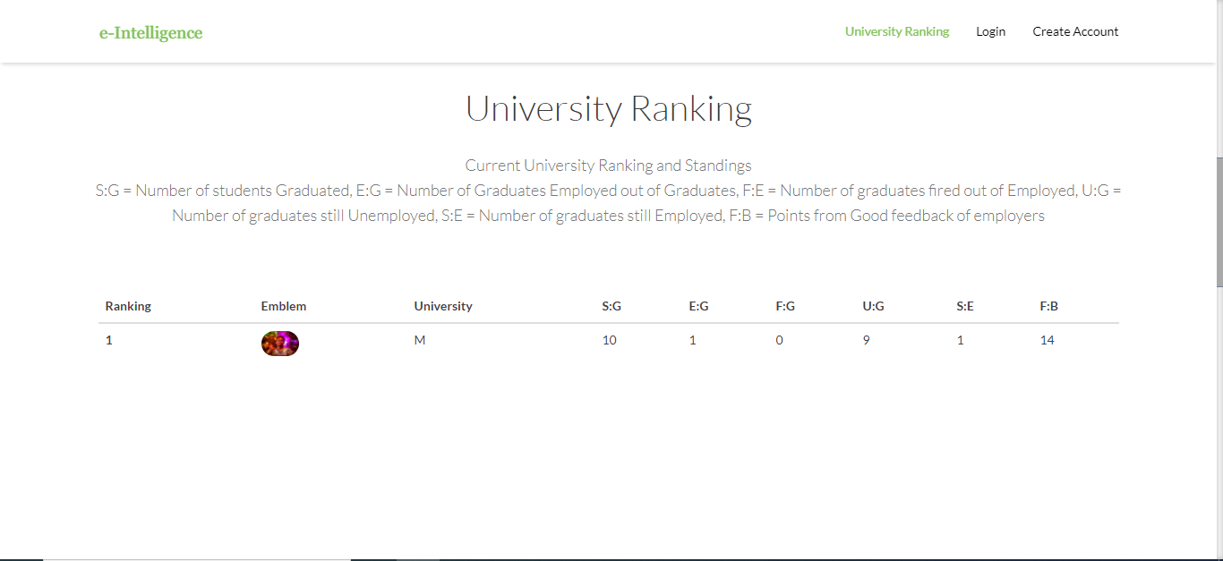
Figure 2 Ranking on review

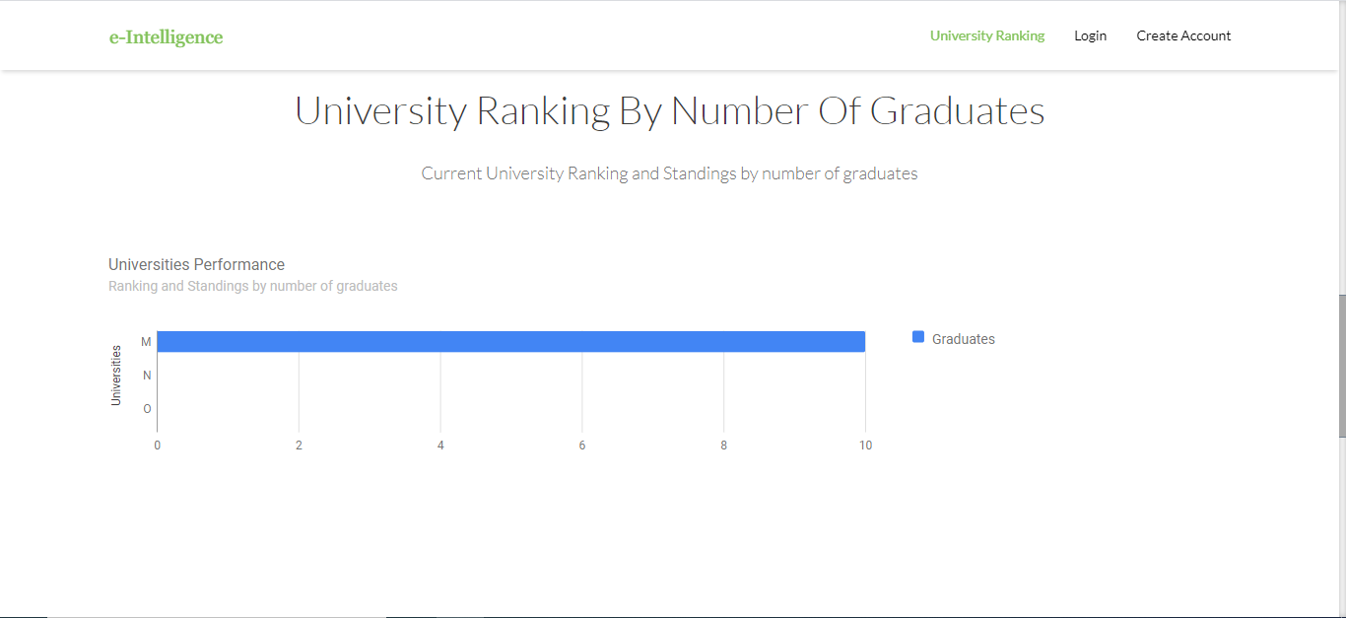
Figure 3 ranking by graduates

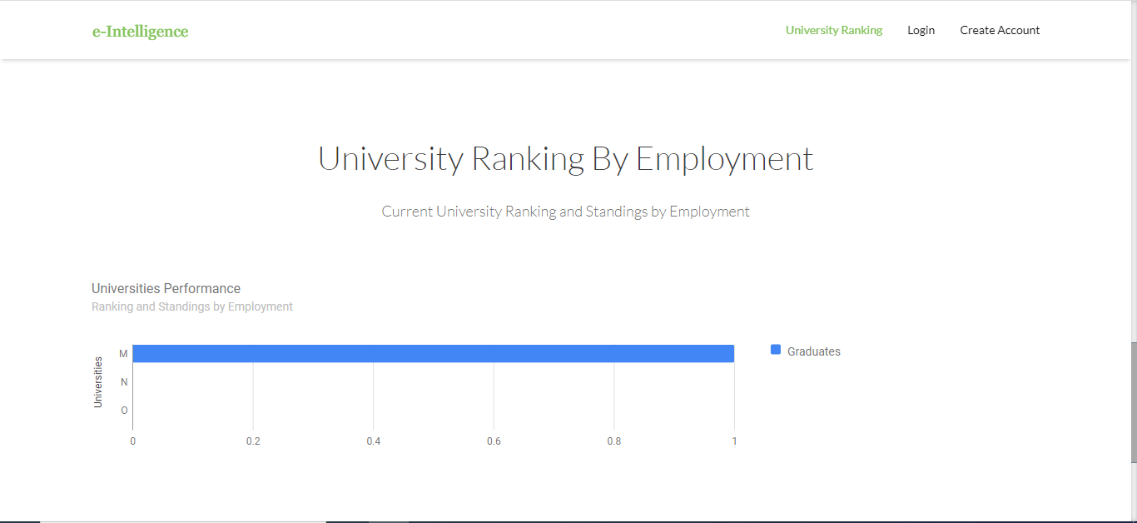
Figure 4 Ranking by employment

How to Create an account and Login

Creating account
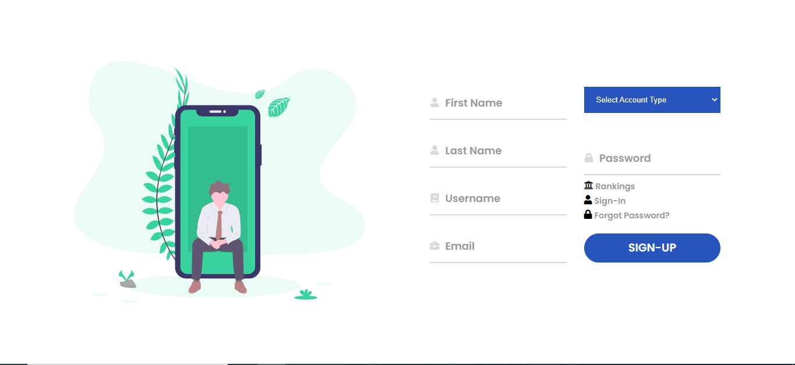
Figure 5 create account

Figure 5 shows the view users access to create the different account types on the system which include students, graduates, employers and academic registrars.


Login

Figure 6 Login

Figure 6 shows the login screen user access when they are to access their accounts on the system.

Account Login for Student
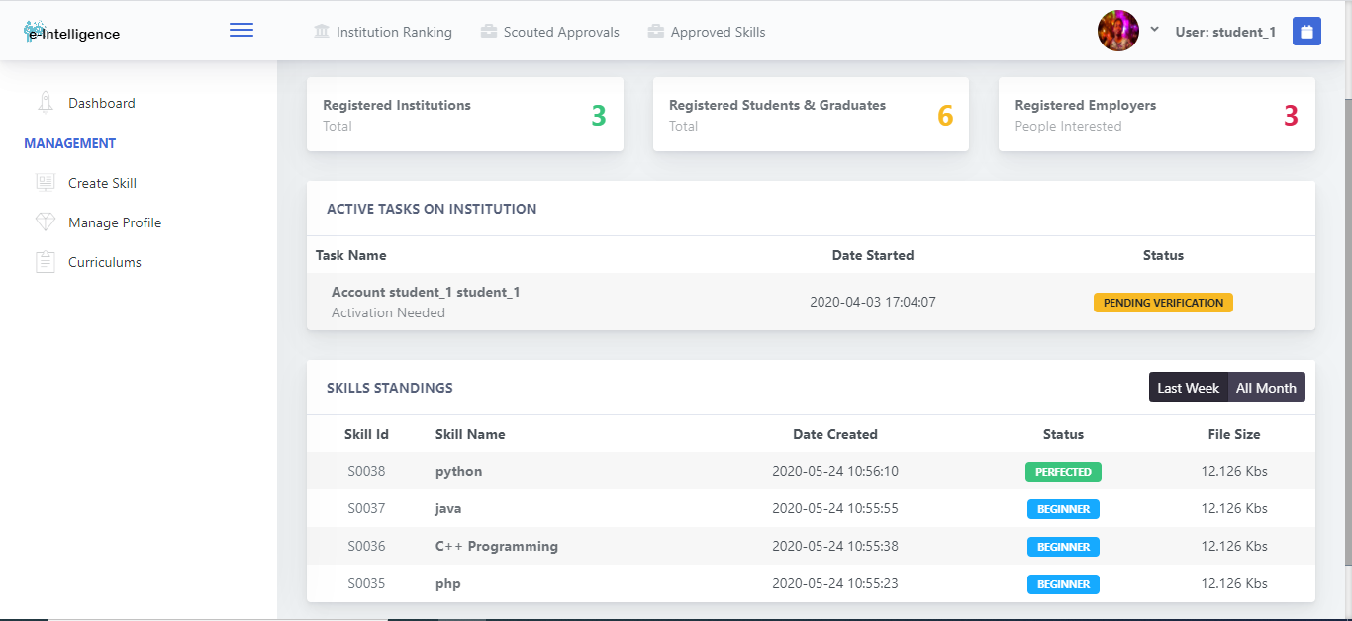
Figure 7 student dashboard

Figure 7 is the student dashboard showing the student if their account has verification information and status of their current skill levels

Account Login for Graduates
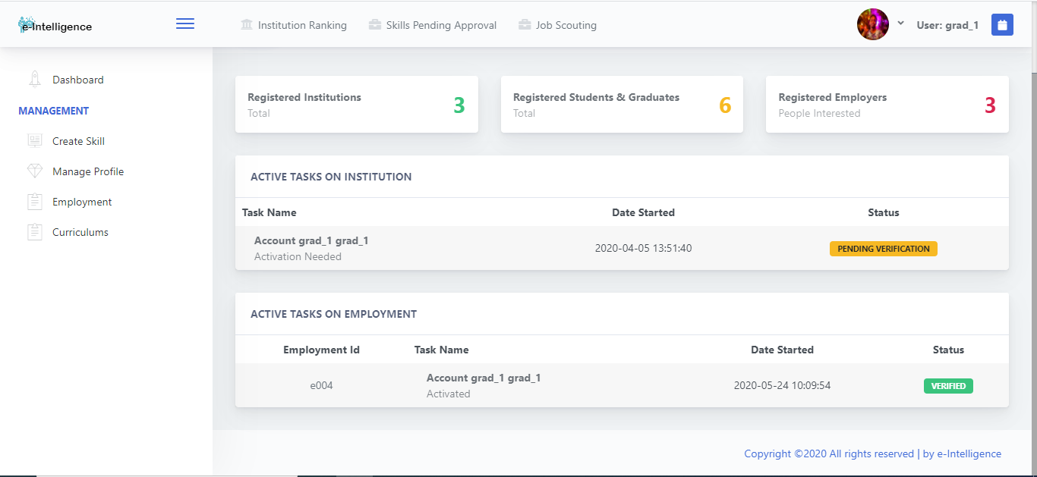

Figure 8 graduate Dashboard

Figure 8 is the graduate dashboard showing the graduate if their account has verification information from both institution and employment.

Account Login for Employer
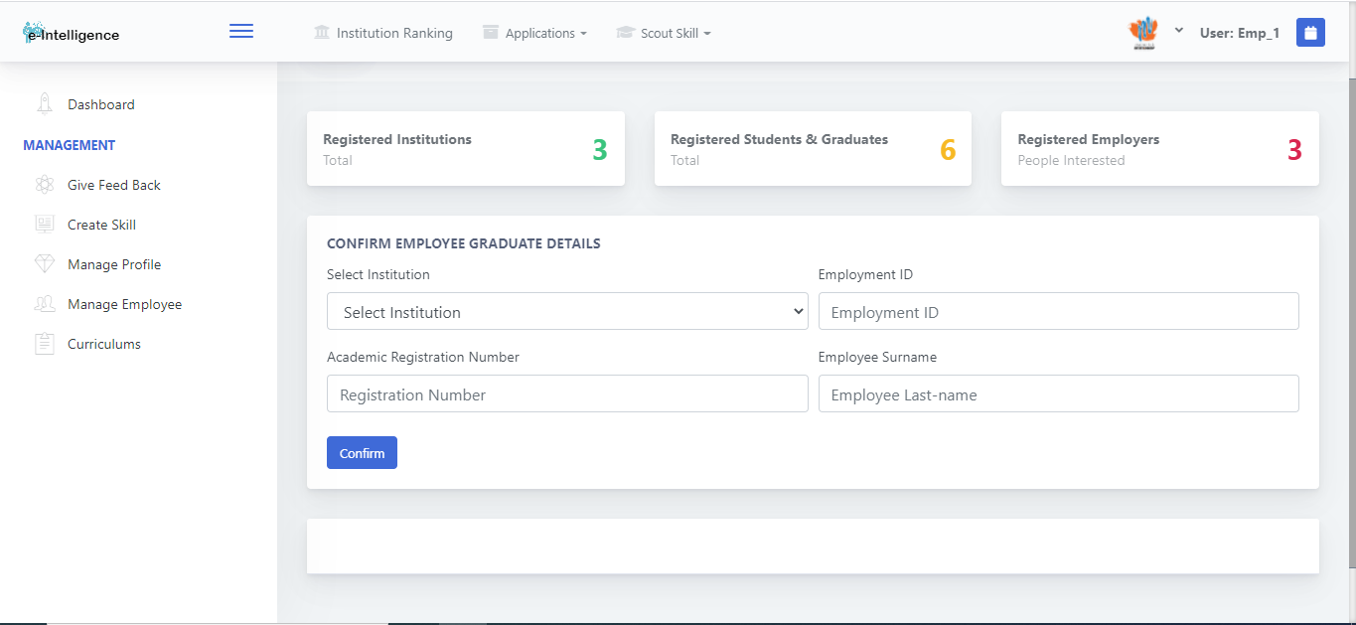

Figure 9 Employer Dashboard

Figure 9 employer dashboard shows the form the user can use to check the credibility of the graduates they employer by entering the required details in the form provided and check results will return with if the graduate completed from the institution they provided or not.

Account Login for Registrar
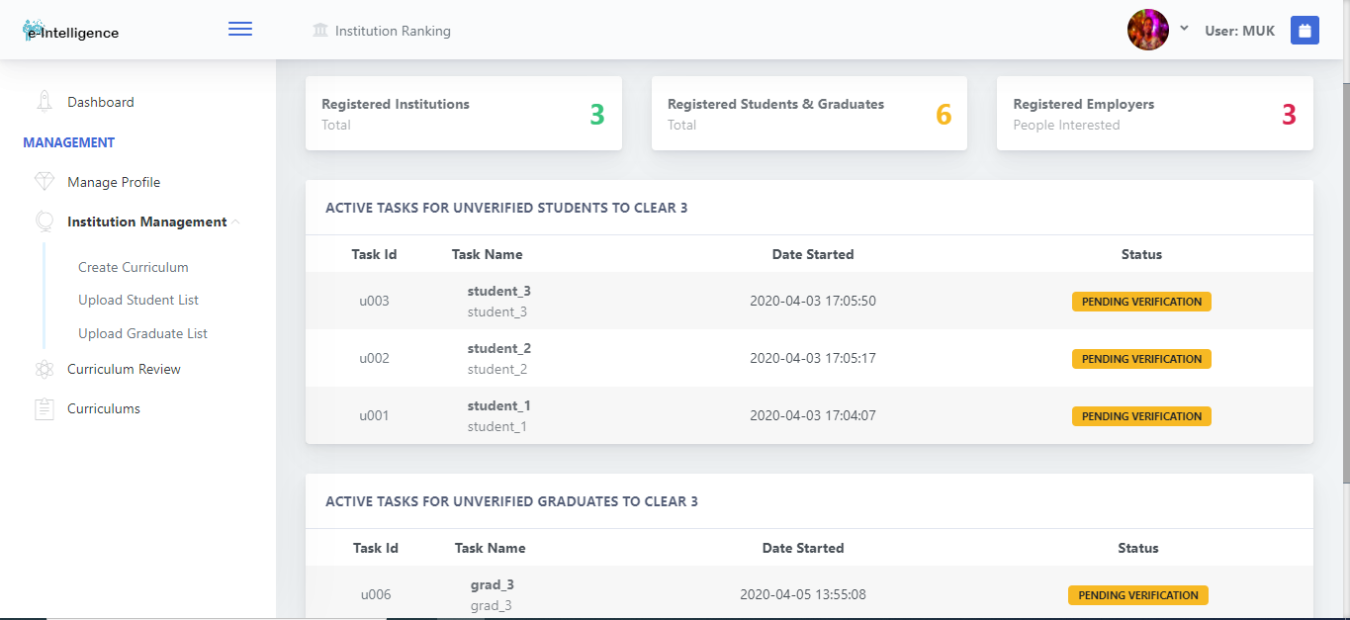

Figure 10 Registrar Dashboard

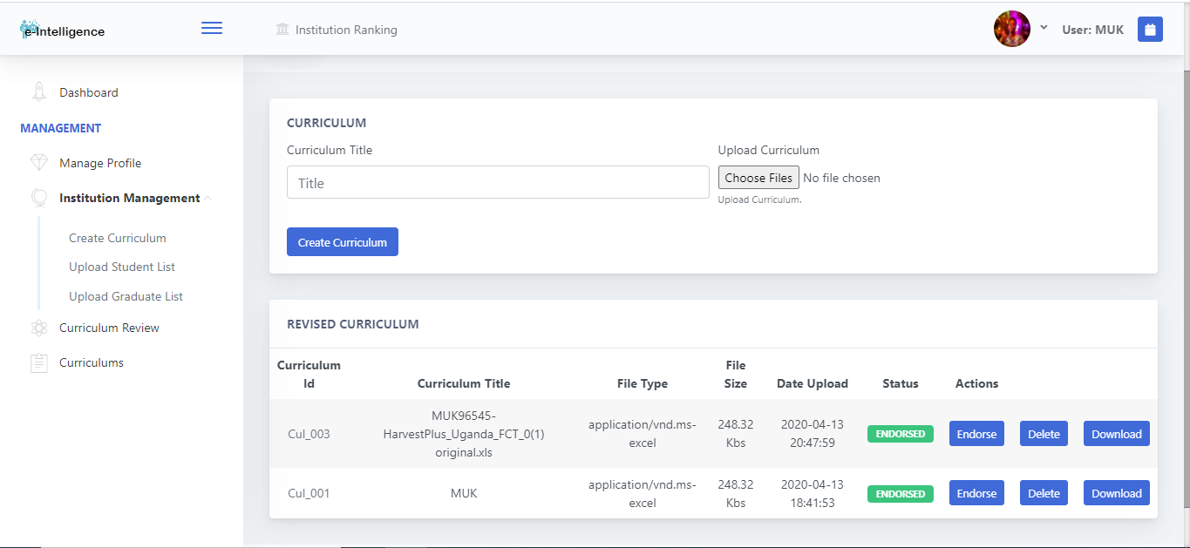
Figure 10 Registrar Dashboard this view shows the registrar all the students and graduates on the system claiming to have or be studying from their institution and need verification from the registrar in order to keep the data integrate in the system for the ranking algorithm. Figure 11, 12 and 13 shows the views the registrar uses to create curriculum, upload student lists per academic year and upload graduation lists per academic year. Note once the student and graduate lists are upload the system automatically verifiers all students account whose names are on the lists by default, therefore the registrar only needs to upload the lists and the system will do the verifications automatically figure 12 and 13. In figure 11 the registrar can create curriculums and endorse the one that is currently active at the institution while being able to delete the ones that are not.
Figure 11 Create Curriculum

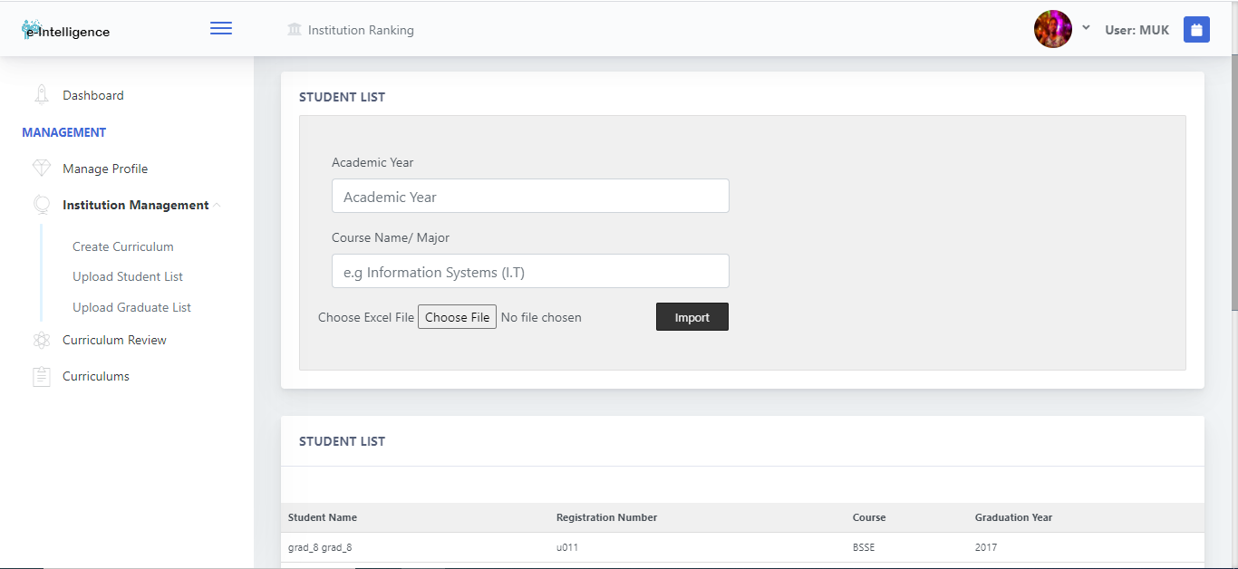
Figure 12 Upload student lists

File type Excel columns Student Names, Registration Number, Course, Academic year, in some order then upload.
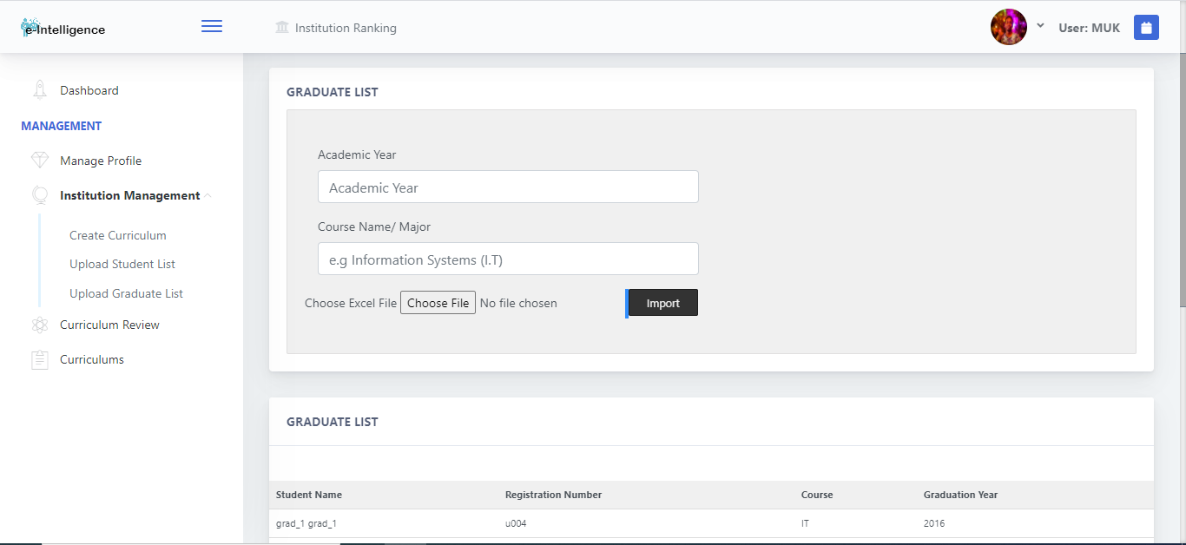
Figure 13 Upload graduate list

File type Excel columns Student Names, Registration Number, Course, Graduation year, in some order then upload.

Creating Skills Account Student, Graduate and Employer
Figure 14 shows the view that students, graduates and employers use to create skills that need to be used for scouting. Students and Graduate create skills that will be scouted by employers and are supported by their institutions while employers create skills that will be map to skills offered by the institutions in order to help the scout out students and graduates with that skill set.
Students and Graduate can specifier where they want to scouted by selecting a company of their choice or select open for any company to scout them while the same for employers, they can specifier which institution they want to scout from or select open to scout from all institutions.
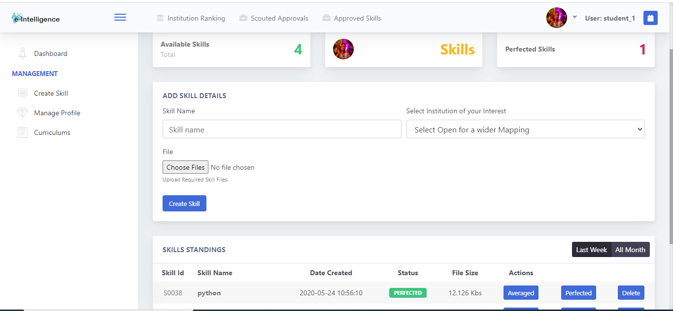
Figure 14 Create Skill

Manage Profile
Figure 15 Updating user profile
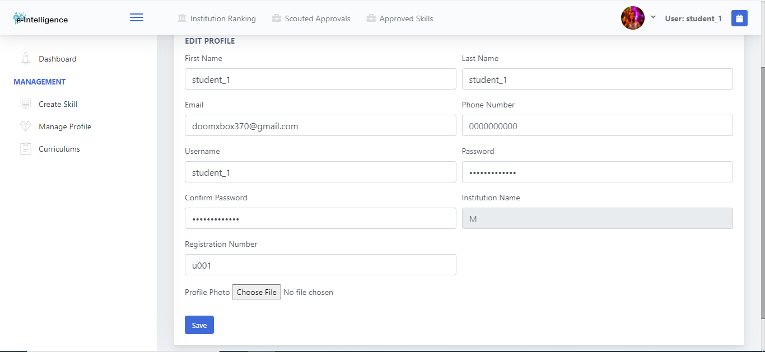

Employer Feedback
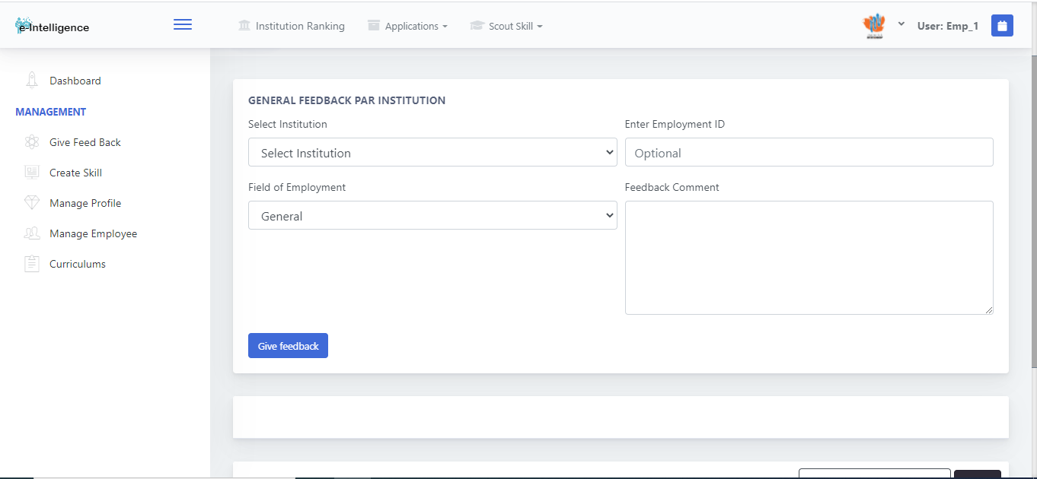
Figure 16, 17 provide the look and feel of the feedback platform the employers use to give their thoughts and take on the institutions and the graduates they employ. The feedback can be specific to an institution, general or just on a particular graduate employed.
Figure 16 Give Feedback

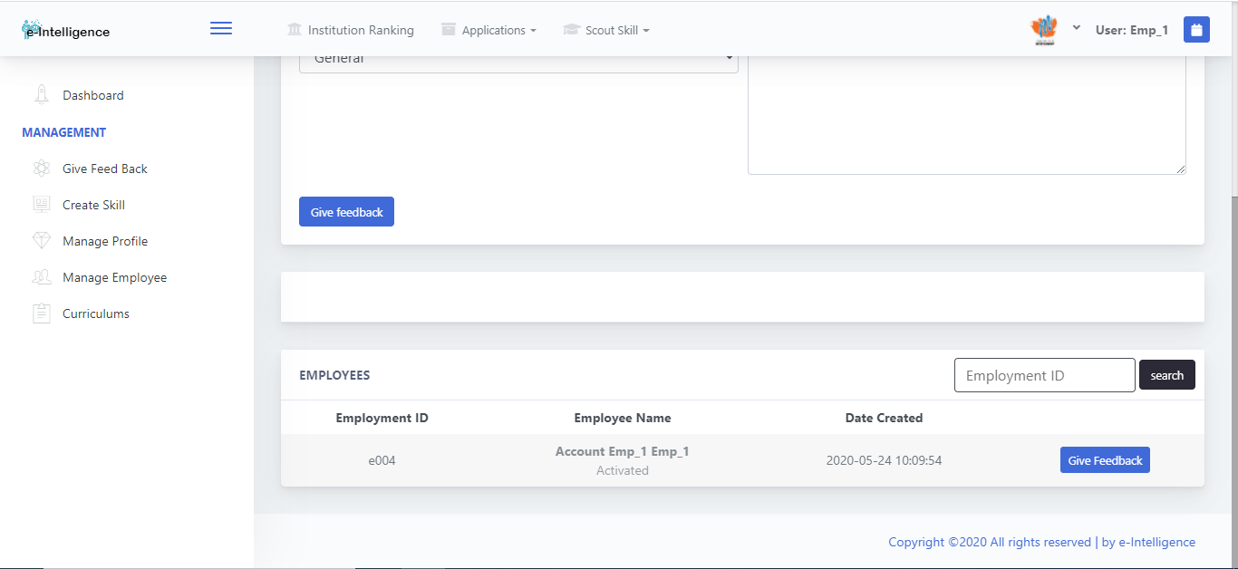
Figure 17give feedback

Account registrar Curriculum Review
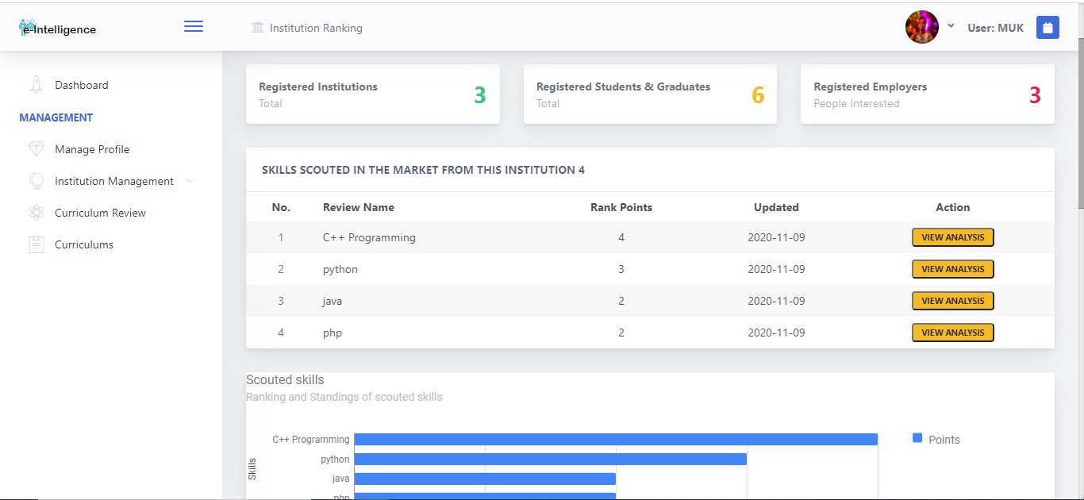
Figure 18, 19, 20, 21 and 22 Show the review and analysis for the different courses and skills offered to institutions in the employment sector under their curriculums, along with what is expected in the market.
Figure 18 Skills offered by the institution and scouted

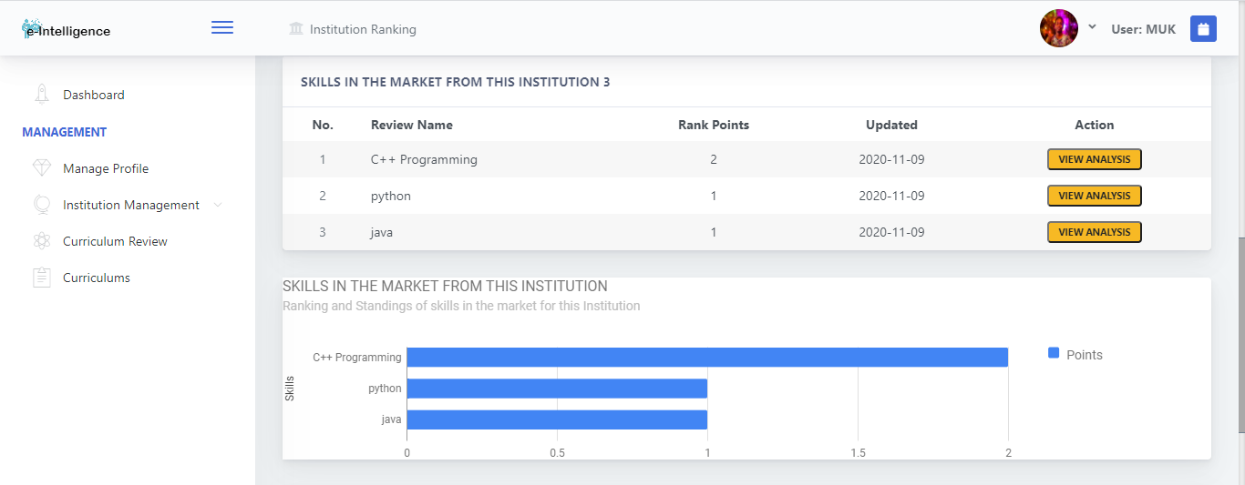
Figure 19 Skills offered by the institution and in the market

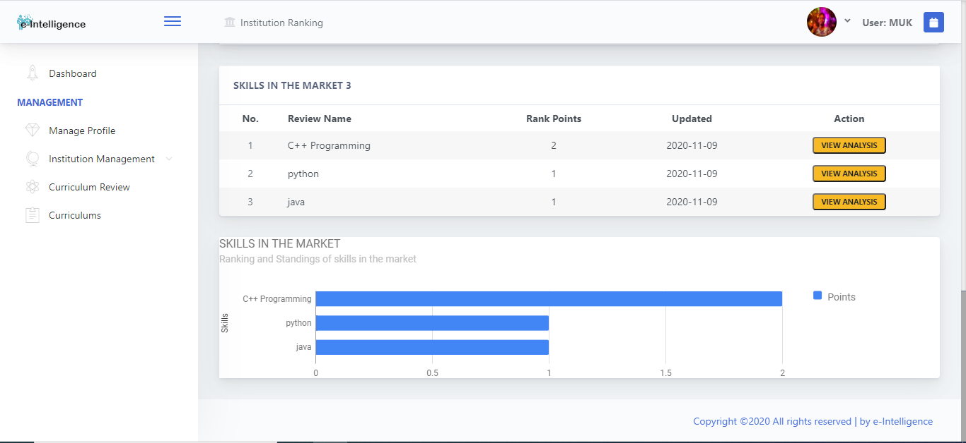

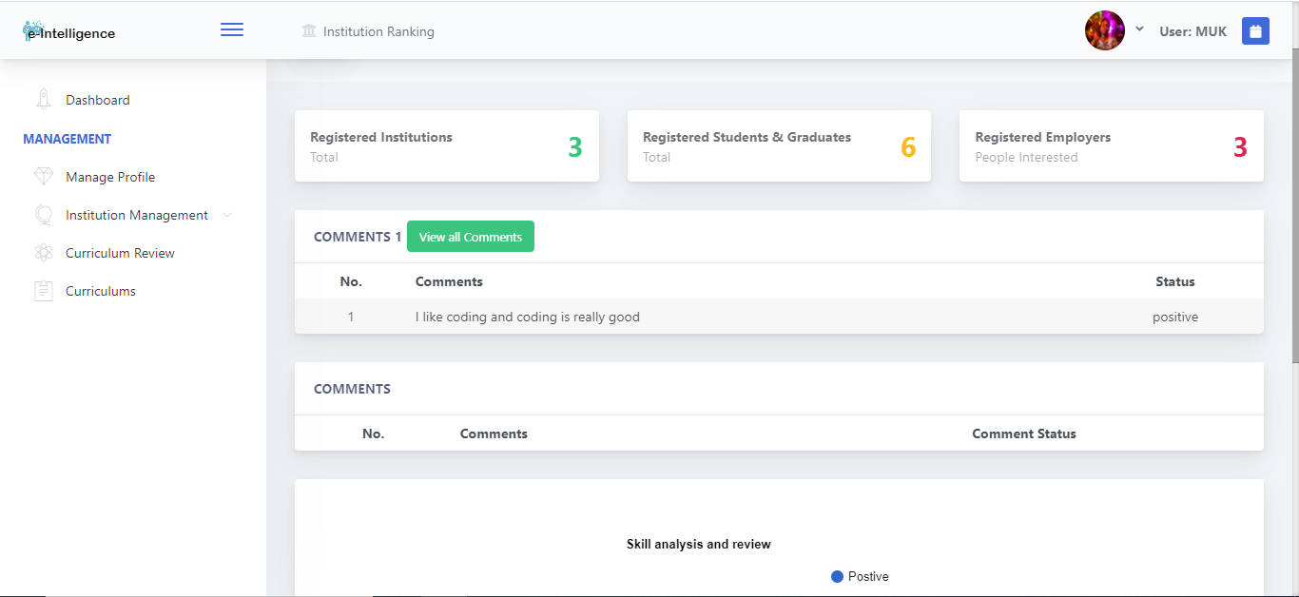
Figure 20 Skills in the market

Figure 21 Skill review

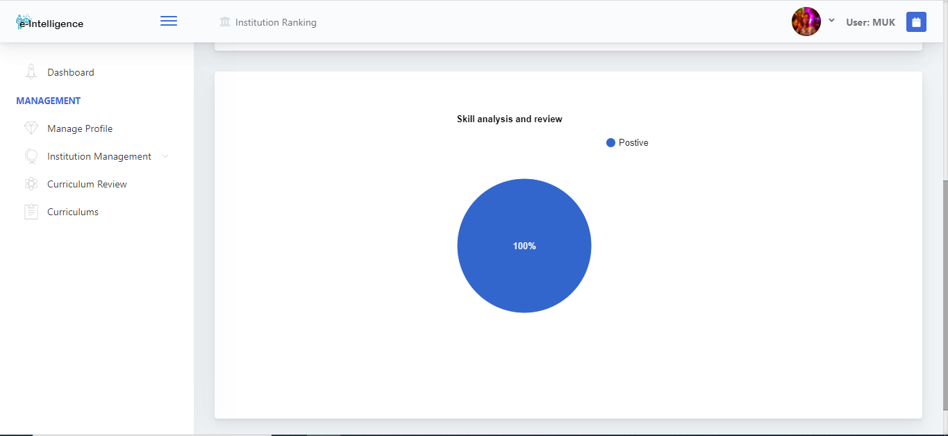
Figure 22 Skill review

